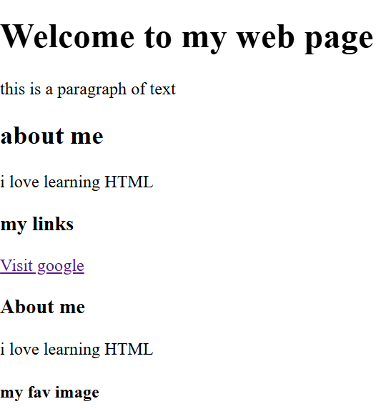
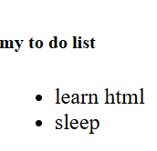
Practical: - To create a basic website
<!DOCTYPE html>
<html>
<body>
<h1>Welcome to my web page </h1>
<p>this is a paragraph of text</p>
<h2> about me </h2>
<p>i love learning HTML</P>
<h3> my links</h3>
<a href= "https://google.com" traget="_blank"> Visit google</a>
<h3>About me</h3>
<p> i love learning HTML </p>
<h4> my fav image</h4>
<img src="C:\Users\Dell\Documents\fav img.png">
<h5> my to do list </h5>
<ul>
<li> learn html</li>
<li> sleep </li>
</ul>
</body>
</html>

